Curve Generation

#include<iostream>
#include<stdio.h>
#include<graphics.h>
#include<math.h>
#include<stdlib.h>
using namespace std;
void move(int j,int h,int &x,int &y)
{
if(j==1) y-=h;
else if(j==2) x+=h;
else if(j==3) y+=h;
else if(j==4) x-=h;
lineto(x,y);
}
void hilbert(int r,int d,int l,int u,int i,int h,int &x,int &y)
{
if(i>0)
{
i--;
hilbert(d,r,u,l,i,h,x,y);
move(r,h,x,y);
hilbert(r,d,l,u,i,h,x,y);
move(d,h,x,y);
hilbert(r,d,l,u,i,h,x,y);
move(l,h,x,y);
hilbert(u,l,d,r,i,h,x,y);
}
}
int main()
{
int n,x1,y1;
int x0=50,y0=150,x,y,h=10,r=2,d=3,l=4,u=1;
cout<<"\nGive the value of n:";
cin>>n;
x=x0;y=y0;
int driver=DETECT,mode=0;
initgraph(&driver,&mode,NULL);
moveto(x,y);
hilbert(r,d,l,u,n,h,x,y);
getch();
closegraph();
return 0;
}

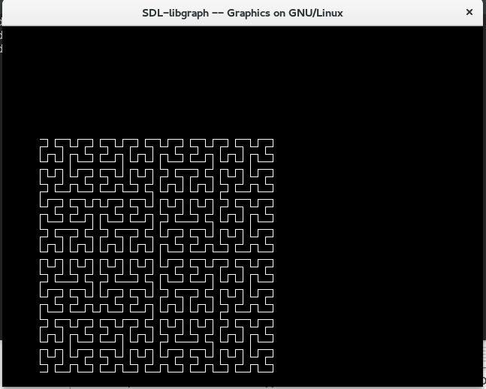

WAVE:

#include<iostream>
#include<graphics.h>
#include<stdio.h>
#include<stdlib.h>

int maxx,maxy;
float xxx[4][2];

void line1(float x2,float y2)
{
line(xxx[0][0],xxx[0][1],x2,y2);
xxx[0][0]=x2;
xxx[0][1]=y2;
}

void bezier(float xb,float yb,float xc,float yc,float xd,float yd,int n)
{

float xab,yab,xbc,ybc,xcd,ycd;
float xabc,yabc,xbcd,ybcd;
float xabcd,yabcd;

if(n==0)
{

line1(xb,yb);
line1(xc,yc);
line1(xd,yd);
}
else
{
xab=(xxx[0][0]+xb)/2;
yab=(xxx[0][1]+yb)/2;
xbc=(xb +xc)/2;
ybc=(yb +yc)/2;
xcd=(xc +xd)/2;
ycd=(yc +yd)/2;

xabc=(xab +xbc)/2;
yabc=(yab +ybc)/2;
xbcd=(xbc +xcd)/2;
ybcd=(ybc +ycd)/2;

xabcd=(xabc +xbcd)/2;
yabcd=(yabc +ybcd)/2;
n=n-1;
bezier(xab,yab,xabc,yabc,xabcd,yabcd,n);
bezier(xbcd,ybcd,xcd,ycd,xd,yd,n);
}
}

int main()
{
int i;
float temp1,temp2;
int gd,gm=VGAMAX;gd=DETECT;
initgraph(&gd,&gm,NULL);

xxx[0][0]=100;
xxx[0][1]=200;

bezier(150,50,200,50,250,200,8);

xxx[0][0]=250;
xxx[0][1]=200;

bezier(300,350,350,350,400,200,8);
getch();
closegraph();
return 0;
}

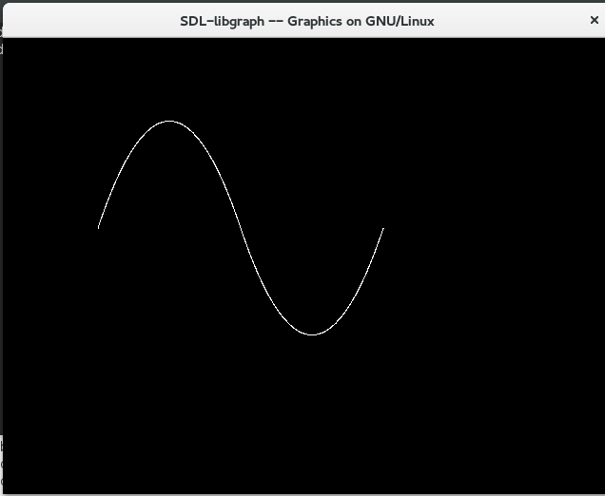

FLOWER:

#include<iostream>
#include<graphics.h>
#include<stdlib.h>
#include<termios.h>
using namespace std;

int maxx,maxy;
float xxx[1][2]={0.0,0.0};
void line1(float,float);
void bezier(float,float,float,float,float,float,int);

int main()
{
int gd,gm=VGAMAX;
gd=DETECT;
initgraph(&gd,&gm,NULL);
maxx=getmaxx();
maxy=getmaxy();
xxx[0][0]=0.5;
xxx[0][1]=0.5;
setcolor(12);
bezier(0.15,0.5,0.25,0.2,0.5,0.5,8);
floodfill(0.45*maxx,0.45*maxy,12);
xxx[0][0]=0.5;
xxx[0][1]=0.5;
setcolor(12);

bezier(0.90,0.45,0.64,0.2,0.5,0.5,4);
floodfill(0.55*maxx,0.45*maxy,12);
xxx[0][0]=0.5;
xxx[0][1]=0.5;
setcolor(12);
bezier(0.15,0.6,0.25,0.87,0.5,0.5,4);
floodfill(0.45*maxx,0.55*maxy,12);
xxx[0][0]=0.5;
xxx[0][1]=0.5;
setcolor(12);
bezier(0.85,0.75,0.57,0.8,0.5,0.5,4);
floodfill(0.55*maxx,0.55*maxy,12);
xxx[0][0]=0.5;
xxx[0][1]=0.5;
setcolor(2);
bezier(0.5,0.75,0.57,0.8,0.5,1,4);
setcolor(14);
circle(0.5*maxx,0.5*maxy,10);
floodfill(0.5*maxx,0.5,14);
xxx[0][0]=0.534;
xxx[0][1]=0.9;
setcolor(2);
bezier(0.85,0.75,0.57,0.78,0.534,0.9,4);
floodfill(0.60*maxx,0.85*maxy,2);
getch();
closegraph();
return 0;
}

void line1(float x2,float y2)
{
int d1,d2,d3,d4;
d1=maxx*xxx[0][0];
d2=maxy*xxx[0][1];
d3=maxx*x2;
d4=maxy*y2;
line(d1,d2,d3,d4);
xxx[0][0]=x2;
xxx[0][1]=y2;
}
void bezier (float xb,float yb,float xc,float yc,float xd, float yd,int n)
{
float xab,yab,xbc,ybc,xcd,ycd;
float xabc,yabc,xbcd,ybcd;
float xabcd,yabcd;

if(n==0)
{

line1(xb,yb);
line1(xc,yc);
line1(xd,yd);
}
else
{
xab=(xxx[0][0]+xb)/2;
yab=(xxx[0][1]+yb)/2;
xbc=(xb +xc)/2;
ybc=(yb +yc)/2;
xcd=(xc +xd)/2;
ycd=(yc +yd)/2;

xabc=(xab +xbc)/2;
yabc=(yab +ybc)/2;
xbcd=(xbc +xcd)/2;
ybcd=(ybc +ycd)/2;

xabcd=(xabc +xbcd)/2;
yabcd=(yabc +ybcd)/2;
n=n-1;
bezier(xab,yab,xabc,yabc,xabcd,yabcd,n);
bezier(xbcd,ybcd,xcd,ycd,xd,yd,n);
}
}

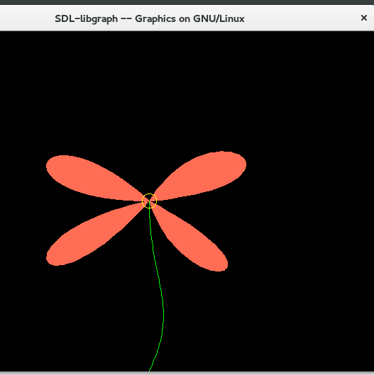

Types Of

Line(Bresanham)
#include<iostream>
#include<graphics.h>
#include<stdlib.h>
#include<math.h>
using namespace std;
class dline
{
private:
int x1,y1,x2,y2,xo,yo,style;
public:
dline()
{
x1=0;
y1=0;
x2=0;
y2=0;
xo=0;
yo=0;

}
void setoff(int x,int y)
{
xo=x;
yo=y;
}
void setstyle(int s)
{
style=s;
}
void drawl(int x1,int y1,int x2,int y2)
{
float x,y,dx,dy,e,temp;
int i,gd,gm,s1,s2,ex,flag;

dx=abs(x2-x1);
dy=abs(y2-y1);
x=x1;
y=y1;
putpixel(x+xo,yo-y,15);
if(x2>x1)
{
s1=1;
}
if(x2==x1)
{
s1=0;
}
if(x2<x1)
{
s1=-1;
}
if(y2>y1)
{
s2=1;
}
if(y2==y1)
{
s2=0;
}
if(y2<y1)
{
s2=-1;
}
if(dy>dx)
{
temp=dx;
dx=dy;
dy=temp;
ex=1;
}
else
{
ex=0;
}
e=2*dy-dx;
i=1;
do
{
while(e>=0)
{
if(ex==1)
{
x=x+s1;
}
else
{
y=y+s2;
}
e=e-2*dx;
}
if(ex==1)
{
y=y+s2;
}
else
{
x=x+s1;
}
e=e+2*dy;
switch(style)
{
case 1: putpixel(x+xo,yo-y,15);
break;
case 2:
if(flag==0)
{
putpixel(x+xo,yo-y,15);
}
if(i%5==0)
{
if(flag==1)
{
flag=0;
}
else
{
flag=1;
}
}
break;
case 3:
if(flag==0)
{
putpixel(x+xo,yo-y,15);
}
else
{
if(i%3==0)
putpixel(x+xo,yo-y,15);
}
if(i%5==0)
{
if(flag==1)
flag=0;
else
flag=1;
}
break;
case 4:
putpixel(x+xo,yo-y,15);
break;
}
i=i+1;
}while(i<=dx);
}
};

int main()
{
int gd,gm=VGAMAX;gd=DETECT;
int i,st,x1,x2,y1,y2,xmax,ymax,xmid,ymid,wx,wy,thickness;

dline l;
cout<<"\nEnter two end points of line:";
cout<<"\nEnter the value of x1:";cin>>x1;
cout<<"\nEnter the value of y1:";cin>>y1;
cout<<"\nEnter the value of x2:";cin>>x2;
cout<<"\nEnter the value of y2:";cin>>y2;

cout<<"\nEnter line Style:";
cout<<"\n1:Simple";
cout<<"\n2:Dash";
cout<<"\n3:Dash Dotted";
cout<<"\n4:Thick";
cout<<"\nEnter correct option:";cin>>st;

if(st==4)
{
cout<<"\nEnter the thickness of line:";cin>>thickness;
}
initgraph(&gd,&gm,NULL);
xmax=getmaxx();
ymax=getmaxy();
xmid=xmax/2;
ymid=ymax/2;
setcolor(15);
l.setoff(xmid,ymid);
l.setstyle(st);
line(xmid,0,xmid,ymax);
line(0,ymid,xmax,ymid);

if(st<=3)
{
l.drawl(x1,y1,x2,y2);
}
else
{
l.drawl(x1,y1,x2,y2);
if((y2-y2)/(x2-x1)<1)
{
wy=(thickness-1)*sqrt(pow((x2-x2),2)+pow((y2-y1),2))/(2*fabs(x2-x1));
for(i=0;i<wy;i++)
{
l.drawl(x1,y1-i,x2,y2-i);
l.drawl(x1,y1+i,x2,y2+i);
}
}
else
{
wx=(thickness-1)*sqrt(pow((x2-x1),2)+pow((y2-y1),2))/(2*fabs(y2-y1));
for(i=0;i<wx;i++)
{
l.drawl(x1-i,y1,x2-i,y2);
l.drawl(x1+i,y1,x2+i,y2);
}

}
}
getch();
closegraph();
return 0;
}
